Irish Squash Training Guide
MCF- 280917 Ver. 1

September 2017
My Club Finances (HQ)
Unit 11 Dockgate
Dock Road
Galway
Ireland
T: +353 91 506048
E: info@myclubfinances.com

This guide is intended to help Squash Club administrators submit member data to Irish Squash HQ using their on MyClubFinances.com club account.
Each September clubs must renew their members. Clubs should ensure to add new member details, update current member details if necessary and remove members that are no longer part of their club. The method of submitting member data is illustrated below.
Please follow the steps below:
Go to www.myclubfinances.com/admin/login.asp and
Log in using your user name and password as supplied by Irish Squash. Call 01 6251145.
You will be presented with this screen after log in.
Step 1 & 2.
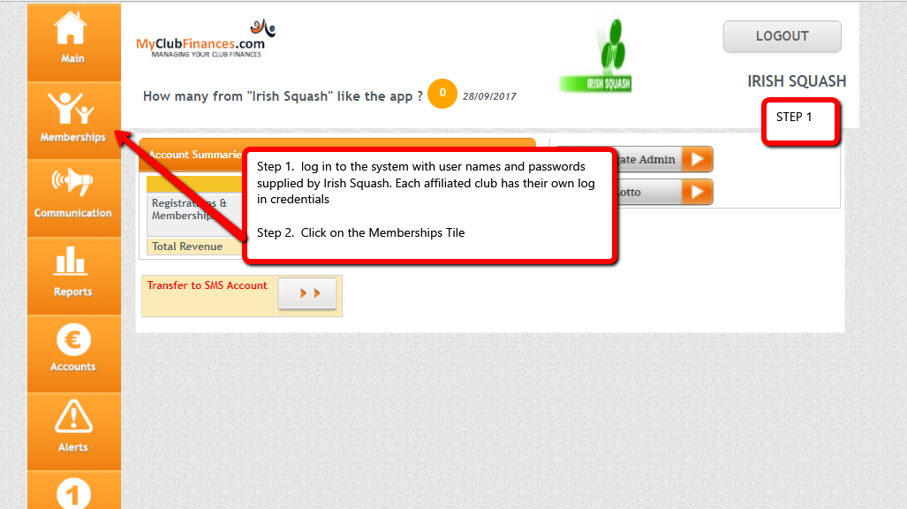
Now follow step 3
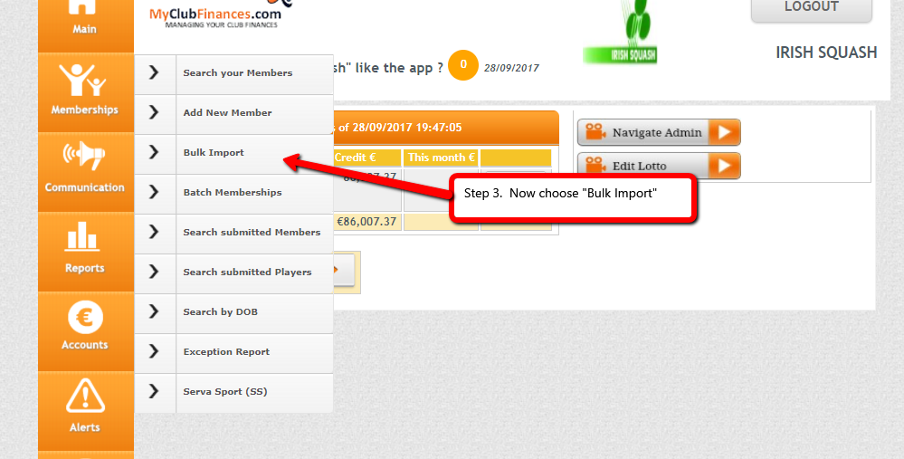
Step 4
You will now need to download a spreadsheet. The spreadsheet has the headings added and a sample member has been added.
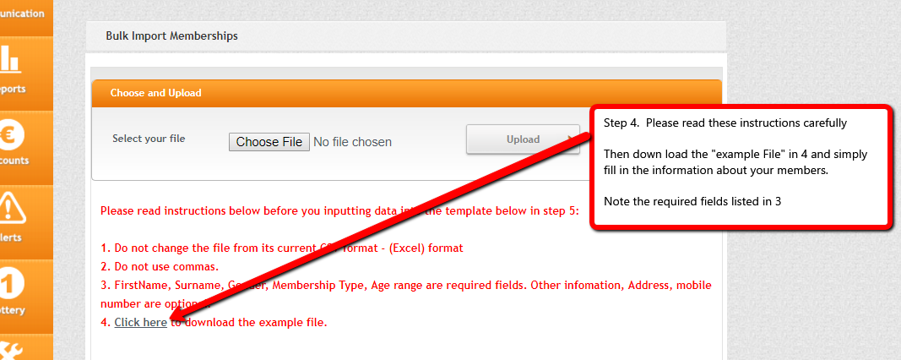
Step 5
Once the file has been downloaded, then start filling in the information on your members. Be careful to add the mandatory fields.
Make sure you delete or overwrite the sample in row 2 “Alen Border”
When entering data for ‘Membership type' and 'Age Grade' you must use the set phrases below and ensure they are spelt correctly when typed on your spreadsheet. Failure to do so will cause your data to change after uploading rendering it incorrect. If this happens you must select the correct drop-down box for each member on the ‘review’ screen and select the correct option.
- The system will only accept the following options for 'Membership type' - Adult League/Competition, Adult Recreational, Associate, Student, Junior and Overseas.
- There are only 3 options the system will accept for the 'Age Grade' - Junior, Senior and Master
- It is essential that when entering ‘membership type’ and ‘age grade’ that you use the categories shown above. If you do not you may have to edit your data on the spreadsheet at the ‘review’ stage.
You can work on this file over time if that is easier for you. Keep saving as you go to your PC.
If the admin panel has timed out when you come back, then log in again and just get back to step 4. There is no need to download the sample spreadsheet again as you have already done this.
The file name can be changed to any name that suits your filing system but please make sure the type stays as .CSV.
You will note that e-mail address is one of the required fields. Please DO NOT USE the same e-mail address for multiple players.

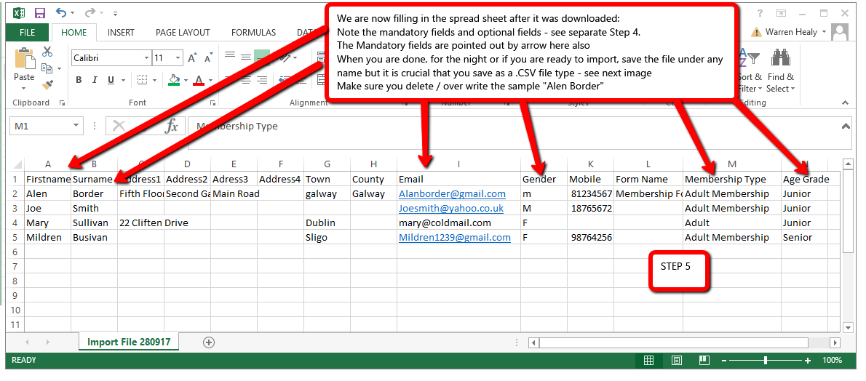

SAVING AS .CSV – THIS IS A CRITICAL STEP
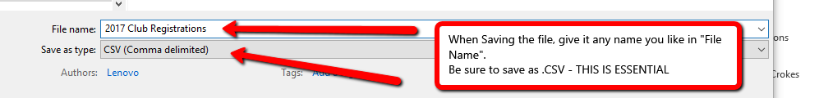
Step 6.
Once the file is complete, you are now ready to import.
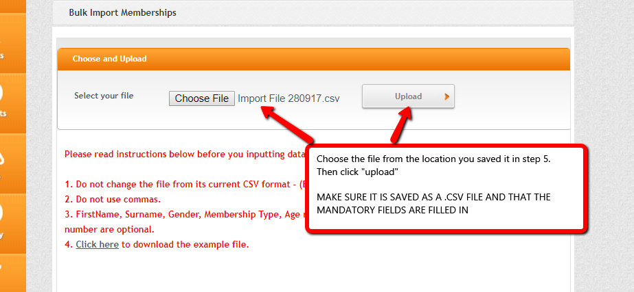

You might get an error like this:
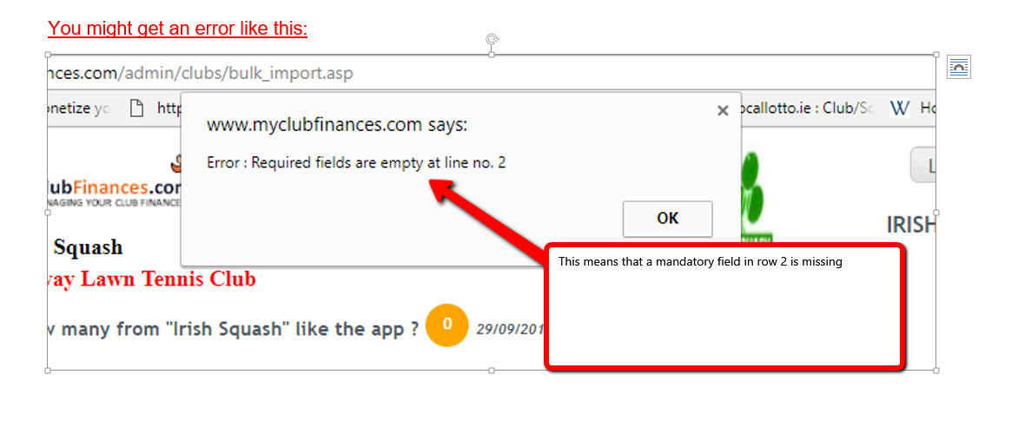

Once the file is successfully uploaded, you are now ready to review and submit and you are almost done. Read the screen carefully.
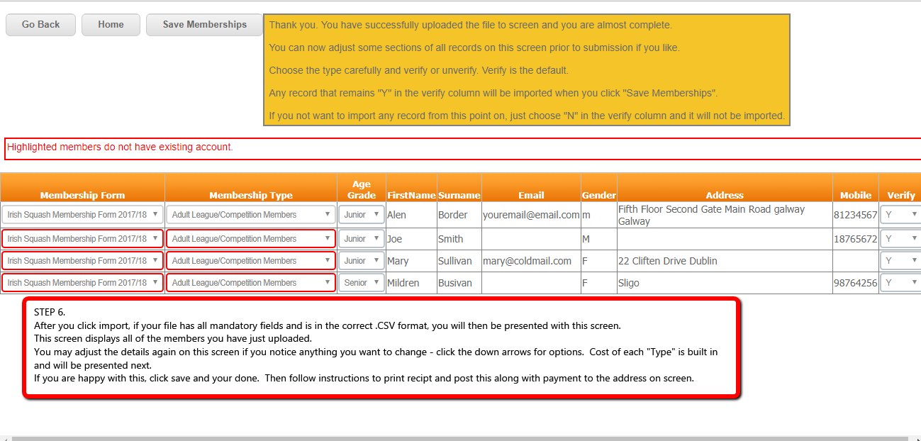

If you have already imported a member for the current year, and you try to import this member again for the same year, you will be prompted of this fact and asked it you really want to do this.
This means you can keep working on the same spread sheet and importing as you proceed and the system will Identify and exclude duplicates.
For instance, you can add 10 members to the spread sheet – save (as a .CSV) and import. When you are ready to add more members, now open the same file, add new members to it and save. Now import the same file as before. The system will identify the original 10 member that you have added to the system and it will exclude them from the import and will only add the new members you added to the spread sheet.
Excluding duplicates is the default so if you do not want to import duplicates, then simply proceed with the import and the duplicates will automatically be excluded.
Final Step
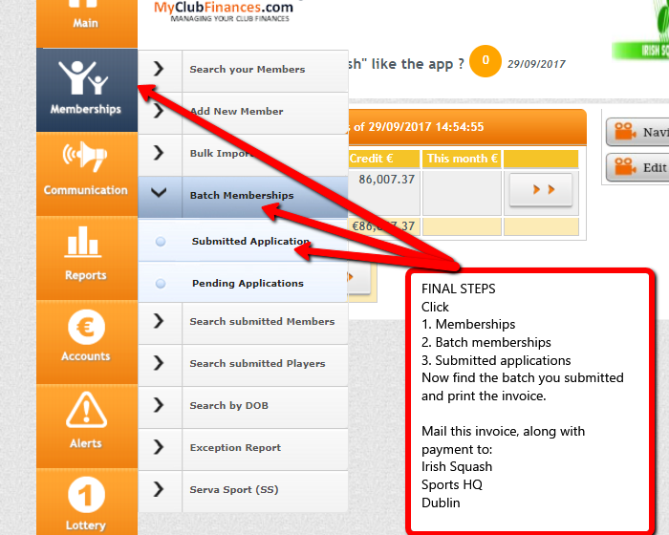

Printing the invoice
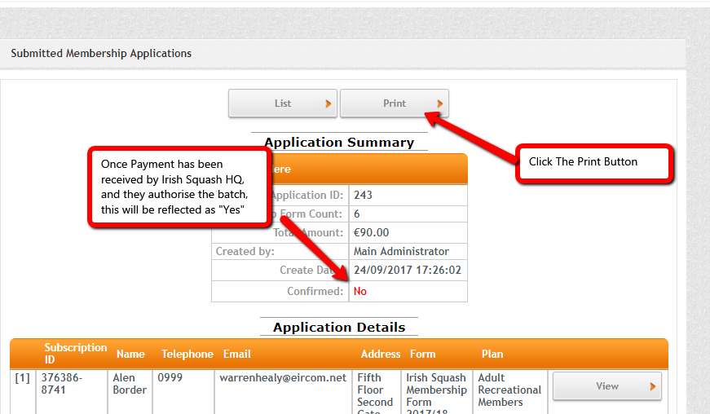

Let us know if there are any suggestions.
Call us on 091 506048 if there are any difficulties

You can also Call Paul at 01 6251145
Irish Squash
Irish Sports Campus
Blanchardstown
Dublin 15
Ireland
MyClubFinances.com

