Barntown Squash Club – The Story so far! | April 9  2015

Table of Contents
1. BACKGROUND AND HISTORY 2
2. OBJECTIVES 2
3. GOVERNANCE 2
4. MARKETING 3
5. MEMBERSHIP 3
6. FINANCING OUR CLUB 5
7. EXECUTING GROWTH FOR OUR CLUB 5
8. APPENDICES 6
8.1 Flyer 6

BACKGROUND AND HISTORY

Barntown Squash Club, once a thriving club in the 80’s & 90’s was re-launched in April 2014 by a group of local enthusiastic squash players. We are located just off the N25 only 3km outside Wexford Town in the Sunny South East of Ireland.
The club utilises the facilities of the Community Centre in Barntown which has one court.
Following election of a new committee in April 2014 we immediately set about re-furbishing the court/facilities which had fallen into major disrepair and was closed for about 15 years. We raised 7k in a month and by the end of the re-furbishment (which took 2 months) we had raised and spent 11k. This was obtained through membership fees, sponsorship and donations. Most of the re-furbishment was carried out in a voluntary capacity by members. See our website, facebook and/or twitter pages for some amazing before/after photos.

OBJECTIVES

  - To foster and develop sporting friendship throughout the game of squash.
  - To work in partnership with Barntown Community Centre to develop the facilities for the benefit of all our members.
  - To develop squash as a healthy, lifelong sport suitable for all ages and family members with particular emphasis on developing junior squash.

GOVERNANCE
We have a strong active committee (7 members) that is re-elected yearly at the AGM.
Our Governing body is Irish Squash whom we continue to work with in terms of advice and support in developing our club and promoting the game of squash in our locality.
The club has an up to date constitution detailing how we conduct our affairs. We also have a detailed Child Protection Policy Statement and two Child Protection officers (1 male, 1 female)

MARKETING

Our identity as a community and family based club is important. We put a lot of thought into our logo and use every opportunity we can from open days, friendlies with other clubs and trips to Irish Squash run tournaments, to build and raise the profile of our club.
Marketing Barntown Squash Club as a friendly, vibrant and well run club to come play squash is at the heart of everything we do. We have and continue to place a huge emphasis on the quality of our facilities and the ease of access in which to play this great sport.
We recognise that an active membership is key to sustaining the overwhelming interest shown in our first season. The Barntown parish is a large geographical area but its close proximity to Wexford Town in particular proved to be a major feeding ground for membership. The court is located next to a large national school which is a major target area for our junior membership and parents (in particular the untapped market of mothers who drop their kids to school daily) Another major feeding ground is the local GAA club, Glynn Barntown.
To help us officially re-launch the club we arranged, in association with Irish Squash, an exhibition game between Derek Ryan and Brian Bryne in September 2014. We used the local newspaper, radio, facebook, twitter and our website to spread the news that Barntown is an active club full of events and inclusive for all levels, young and old, male and female. The large crowd in attendance on the night and subsequent coverage that followed in the local paper really helped to generate interest and increased our membership numbers dramatically.
We have held open days, handed out flyers and continue to use the church newsletter to deliver our messages.
We also strategically placed some signage on the main N25 road directing potential members to our clubhouse. This proved extremely rewarding for attracting non locals and those not on facebook etc. Wexford General Hospital is located just 3km and we seen quite a few medical professionals from Pakistan in particular join up as a result of the signs on the main road!

MEMBERSHIP

Membership of the club is open to anyone regardless of their gender, civil or family status, age, religion, race, disability, sexual orientation or membership of the travelling community. It is the policy of the club that no member will be discriminated against on any of the above mentioned nine distinct grounds. The club is committed as a matter of policy to ensuring that all members of the community are fully included in its activities.

Membership opened in July 2014 and as at April 2015 we had c200 members (50% male, 30% female and 20% juniors). Approximately 15% of adult members are over 60 yrs old. We had to freeze membership in Jan 2015 as the demand for court time exceeded availability.
The cost of membership is as follows with 15/10 euro of the fee going directly to Irish Squash for affiliation and insurance.
Adult - €45
OAP/Unemployed €40
Student - €35
Junior (under 18) - €30
Family – 20% discount for 2 Adults and 2 Children.
We put a lot of thought into what we could offer members in order to attract them into the club and more importantly, how we could keep them once signed up. We looked at it from a members perspective and we constantly talk to members to get their feedback re the club, facilities etc.
Key to our membership is the excellent benefits package we offer:
- Free parking facilities.
- 24/7 access with your own set of keys.
- Only €2 p.p per game
- 20% family membership discount (2 Adults & 2 Children)
- Access to play on a recently renovated, fully heated court with an excellent viewing gallery.
- Full Access to Play in in-house Box Leagues, Club Nights, and forthcoming County Championships
- A newly launched Junior Coaching Academy.
- Online court booking system and online access to track and record your progress in our Box Leagues.
- Easy online payment scheme for membership.
- Access to Coaching.
- Access to Coaching and Referee Courses.
- Access to discounted in-house racket re-stringing service.
- Receipt of Monthly Newsletter to keep you updated.
- Member’s social events including trips to see National Squash Championships etc.
- 10% Discount price on Squash Gear with Ned Buggy Sports, Hores Stores and online at www.rackets.ie
- Discounted price on own club gear i.e. hoodies, polo shirts etc.

FINANCING OUR CLUB

Fundraising & sponsorship are a major focus for our Club and we are particularly grateful to our sponsors who have helped us get the club established and continue to support us with our objectives.
The club has three main income streams
- Membership Fee’s
- Sponsorship
- Donations/Fund Raising

Special Offers
As soon as the club was officially re-launched in April 2014 we announced a special offer rate re membership/sponsorship. If you joined/sponsored us in April 2014 you got 18 months membership/sponsorship for the price of 12. Our year end is Sept 2015. This proved a very attractive offer and resulted in a huge influx of members and sponsors in a very short space of time. The main reason behind this was to generate funds quickly so that we could re-furbish the court/facilities.
We have no major or regular running costs per say as a club. The cost of the lights is 4euro per game but the money generated from this goes directly to the community centre and they in turn use it to pay for heating/lighting etc.

EXECUTING GROWTH FOR OUR CLUB
We are particularly interested in increasing the overall number of players playing squash in the area and to improve the standard of the existing players through coaching. We do this through…
- Club nights
- Team leagues
- Box leagues
- Ladder
- Club Championship
- Junior coaching
- World squash day
- Open days
- Exhibition games
- Inter club friendlies
Furthermore, we have opened up discussions with other clubs in the South East with a view to starting a South East League. It is also hoped that we can re-establish a Co. Wexford association and re-start a county championship.

APPENDICES

8.1 Flyer

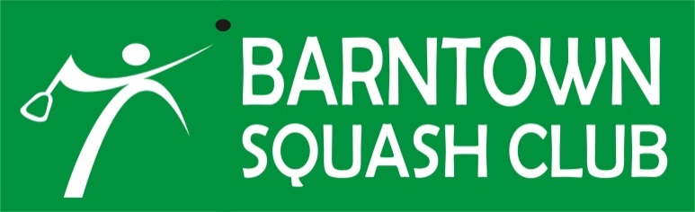  BARNTOWN SQUASH COURT  HAS RE-OPENED  NEW MEMBERS WELCOME!  Adult: €45  OAP/Unemployed: €40  Student: €35  Junior (under 18): €30  Family (2 Adults & at least 2 Children): less 20% discount off total  WHAT WE OFFER YOU  - Free parking and 24/7 access  - Only €2 p.p per game  - Online court booking system  - Access to coaching  - In-house leagues and ladders  - 10% discount on squash gear in local stores  - Club Nights  - New Junior Section  FOR FURTHER DETAILS CONTACT  John @ 087-6558855 or Bernie @ 086-3868277  info@barntownsquashclub.com  www.barntownsquashclub.com |  | 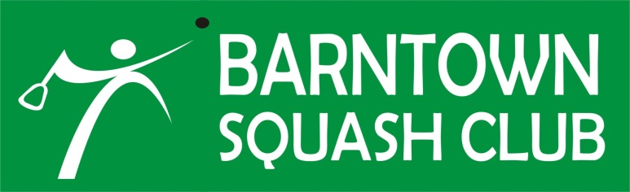  BARNTOWN SQUASH COURT  HAS RE-OPENED  NEW MEMBERS WELCOME!  Adult: €45  OAP/Unemployed: €40  Student: €35  Junior (under 18): €30  Family (2 Adults & at least 2 Children): less 20% discount off total  WHAT WE OFFER YOU  - Free parking and 24/7 access  - Only €2 p.p per game  - Online court booking system  - Access to coaching  - In-house leagues and ladders  - 10% discount on squash gear in local stores  - Club Nights  - New Junior Section  FOR FURTHER DETAILS CONTACT  John @ 087-6558855 or Bernie @ 086-3868277  info@barntownsquashclub.com  www.barntownsquashclub.com

