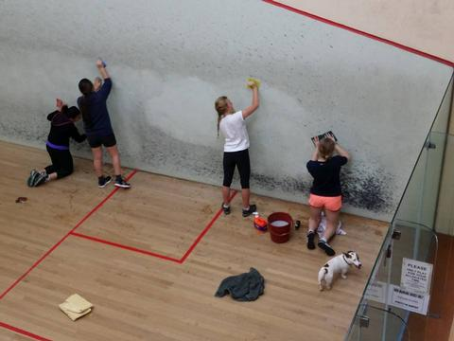
Cleaning squash court walls

Squash court walls should ideally be cleaned once a year. This will improve the reflective light and overall appearance within the court. Before attempting to carry out any minor repairs or cleaning, the floor must be protected. Covering the floor with plastic sheets will reduce the chance of water damage.
Marks on the walls are mainly caused by graphite and similar type materials used for racket heads. Grease marks caused by body contact on the back and side walls should be completely removed otherwise these will penetrate the surface and become a permanent problem. You are advised to contact the supplier of the material before attempting to clean the surface as they should be able to provide a suitable cleaner.
Plaster walls
Start by testing a small area using a diluted degreasing-type cleaner. Allow the area to dry to test the effectiveness of the cleaner. A nylon scouring pad may be used to remove stubborn marks. In no circumstances should an acidic cleaner be used on a plastered surface as this will remove a thin layer of the material and will become powdery. A mild detergent (anionic) may be brushed or sponged on and rinsed with clean water.
Panel systems
Ball marks can often be removed using a damp cloth. For more extreme cleaning, wash down using a mild domestic degreaser cleaner. Rinse with clean water.
Painted surfaces
Both concrete and panel systems that have been painted may be washed down using a mild domestic degreaser diluted. Use a foam type pad to remove ball marks and stubborn stains. Wash down with clean water.
Glass-back walls
Use a spirit based cleaner suitable for glass on a regular basis.

