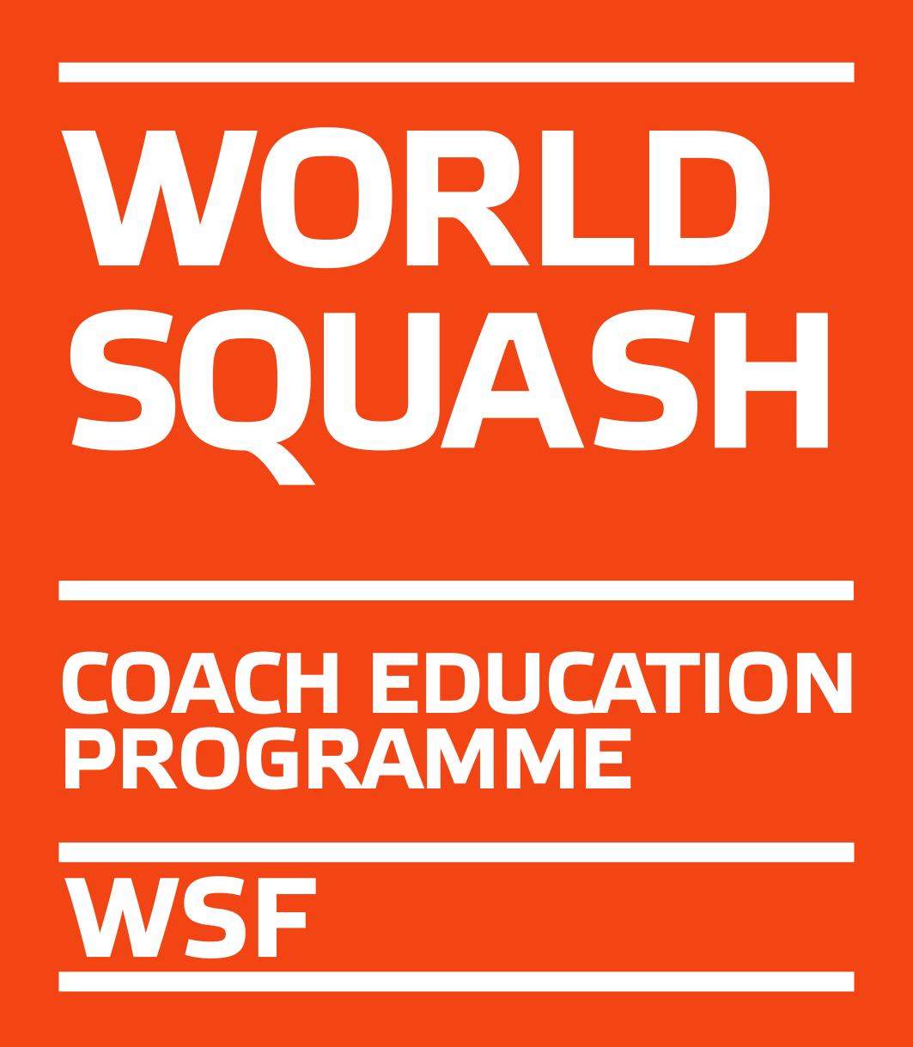

WSF Level 1 Coaching Course

Dates Sat. 6th & Sun 7th July (second 2 dates to be decided)

(Cork, Munster)

On behalf Irish Squash we are pleased to invite you to a WSF Level 1 Coaching course.

Course tutor and organizer: Eddie Murphy
Tutor’s email: eddie.murphy@openeir.ie

THE VENUE
Sunday’s Well Boating and Tennis Club

Course Duration: The course will run for 4 days from 9AM - 5PM with assessment on the final day. The dates for the final 2 days of the course will be agreed with the tutor at the end of the second day.

COURSE FEE

The course fee of €275 must to be paid upon entry to following bank account net of bank charges:
Bank: AIB Crumlin Cross West, Dublin 12
Sort Code: 93-31-12
Account no.: 09565067
IBAN: IE85 AIBK 9331 1209 5650 67
Account Name: Irish Squash Federation
Reference: (Your Name) Irish Squash WSF 1

As this course is part of the WSF Coach Education Programme, participants must register with their SPIN on the WSF website (www.worldsquash.org) as L1 Coach Candidate, which costs GBP 16. Please do this before the course starts. Please contact info@irishsquash.ie if you have problems with registration.

LEVEL 1

APPLICATION FORM

Send to:
irishsquash@gmail.com
Venue: Sunday’s Well Boating and Tennis Club
Dates: Sat. 6 & Sun. 7th July (dates of 3rd and 4th day to be decided)
Time: 9.00AM -5.00PM each day
CLOSING DATE: 5th June 2019

Name ________________________________________

Address ________________________________________

Tel ________________________________________

E-mail ________________________________________

Club where you will coach ________________________________________

Course Fee: €275.00. The course fee must be paid to Irish Squash at least 20 days before the start date of course in order to validate entry.

Please note:
Irish Squash reserves the right to cancel the course if there are insufficient entries to make delivery of course viable!

