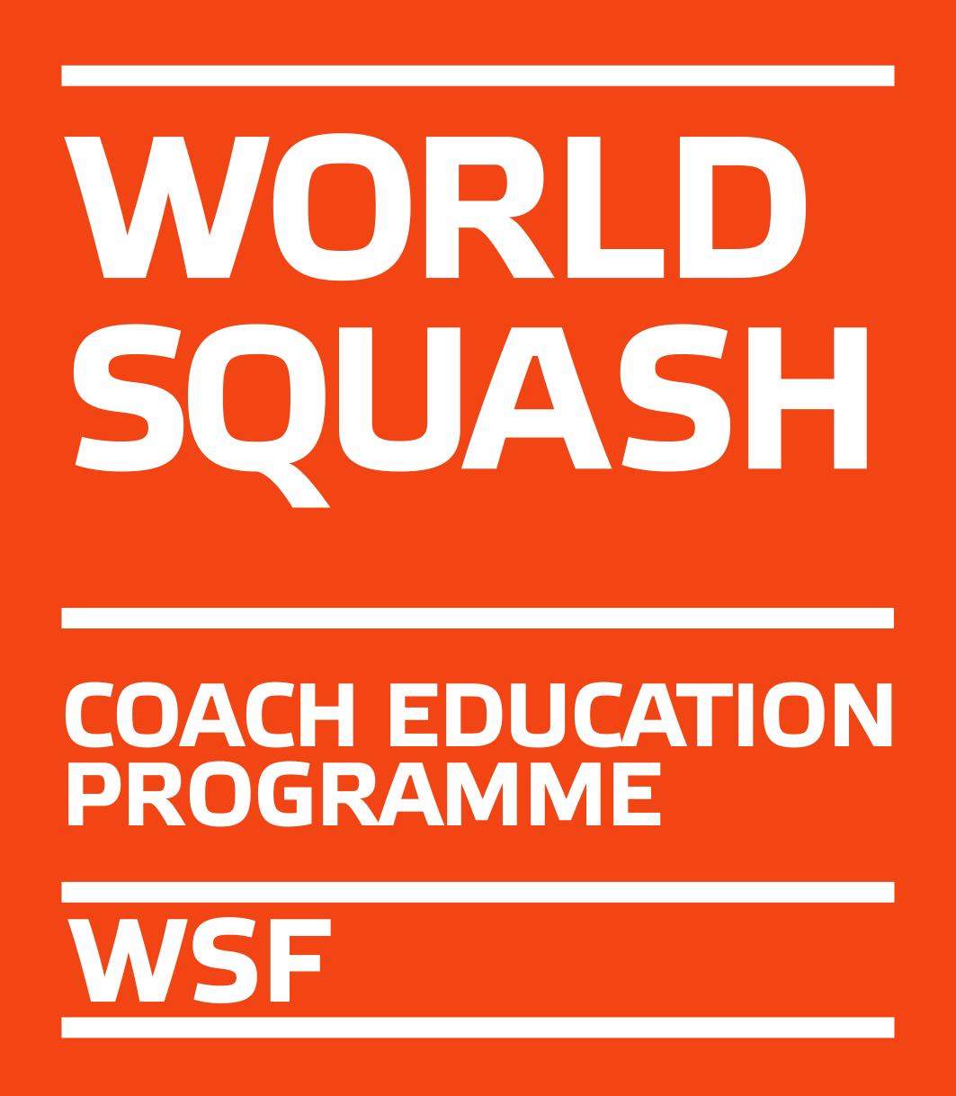

WSF Level 1 Coaching Course

Dates: 5th 6th 13th & 14th August 2019

(Lisburn, Ulster)

On behalf Irish Squash we are pleased to invite you to a WSF Level 1 Coaching course.

Course tutor and organizer: Kieran Doherty
Tutor’s email: glensofantrim@hotmail.com

THE VENUE
Lisburn Racquets Club
36 Belfast Road
Lisburn
Northern Ireland
BT27 4AS

Course Duration: The course will run for 4 days from 9AM-5PM with assessment on the final day.

COURSE FEE

The course fee of €275 must to be paid upon entry to following bank account net of bank charges:
Bank: AIB Crumlin Cross West, Dublin 12
Sort Code: 93-31-12
Account no.: 09565067
IBAN: IE85 AIBK 9331 1209 5650 67
Account Name: Irish Squash Federation
Reference: (Your Name) Irish Squash WSF 1Ulster

As this course is part of the WSF Coach Education Programme, participants must register with their SPIN on the WSF website (www.worldsquash.org) as L1 Coach Candidate, which costs GBP 16. Please do this before the course starts. Please contact info@irishsquash.ie if you have problems with registration.

LEVEL 1

APPLICATION FORM

Send to:
irishsquash@gmail.com
Venue: Lisburn Racquets Club
Dates: 5,6,13 &14th August 2019
Time: 9.30AM -5.30PM each day
CLOSING DATE: 3rd July 2019

Name ________________________________________

Address ________________________________________

Tel ________________________________________

E-mail ________________________________________

Club where you will coach ________________________________________

Course Fee: €275.00. The course fee must be paid to Irish Squash at least 30 days before the start date of course in order to validate entry.

Please note:
Irish Squash reserves the right to cancel the course if there are insufficient entries to make delivery of course viable!

