Masters Report
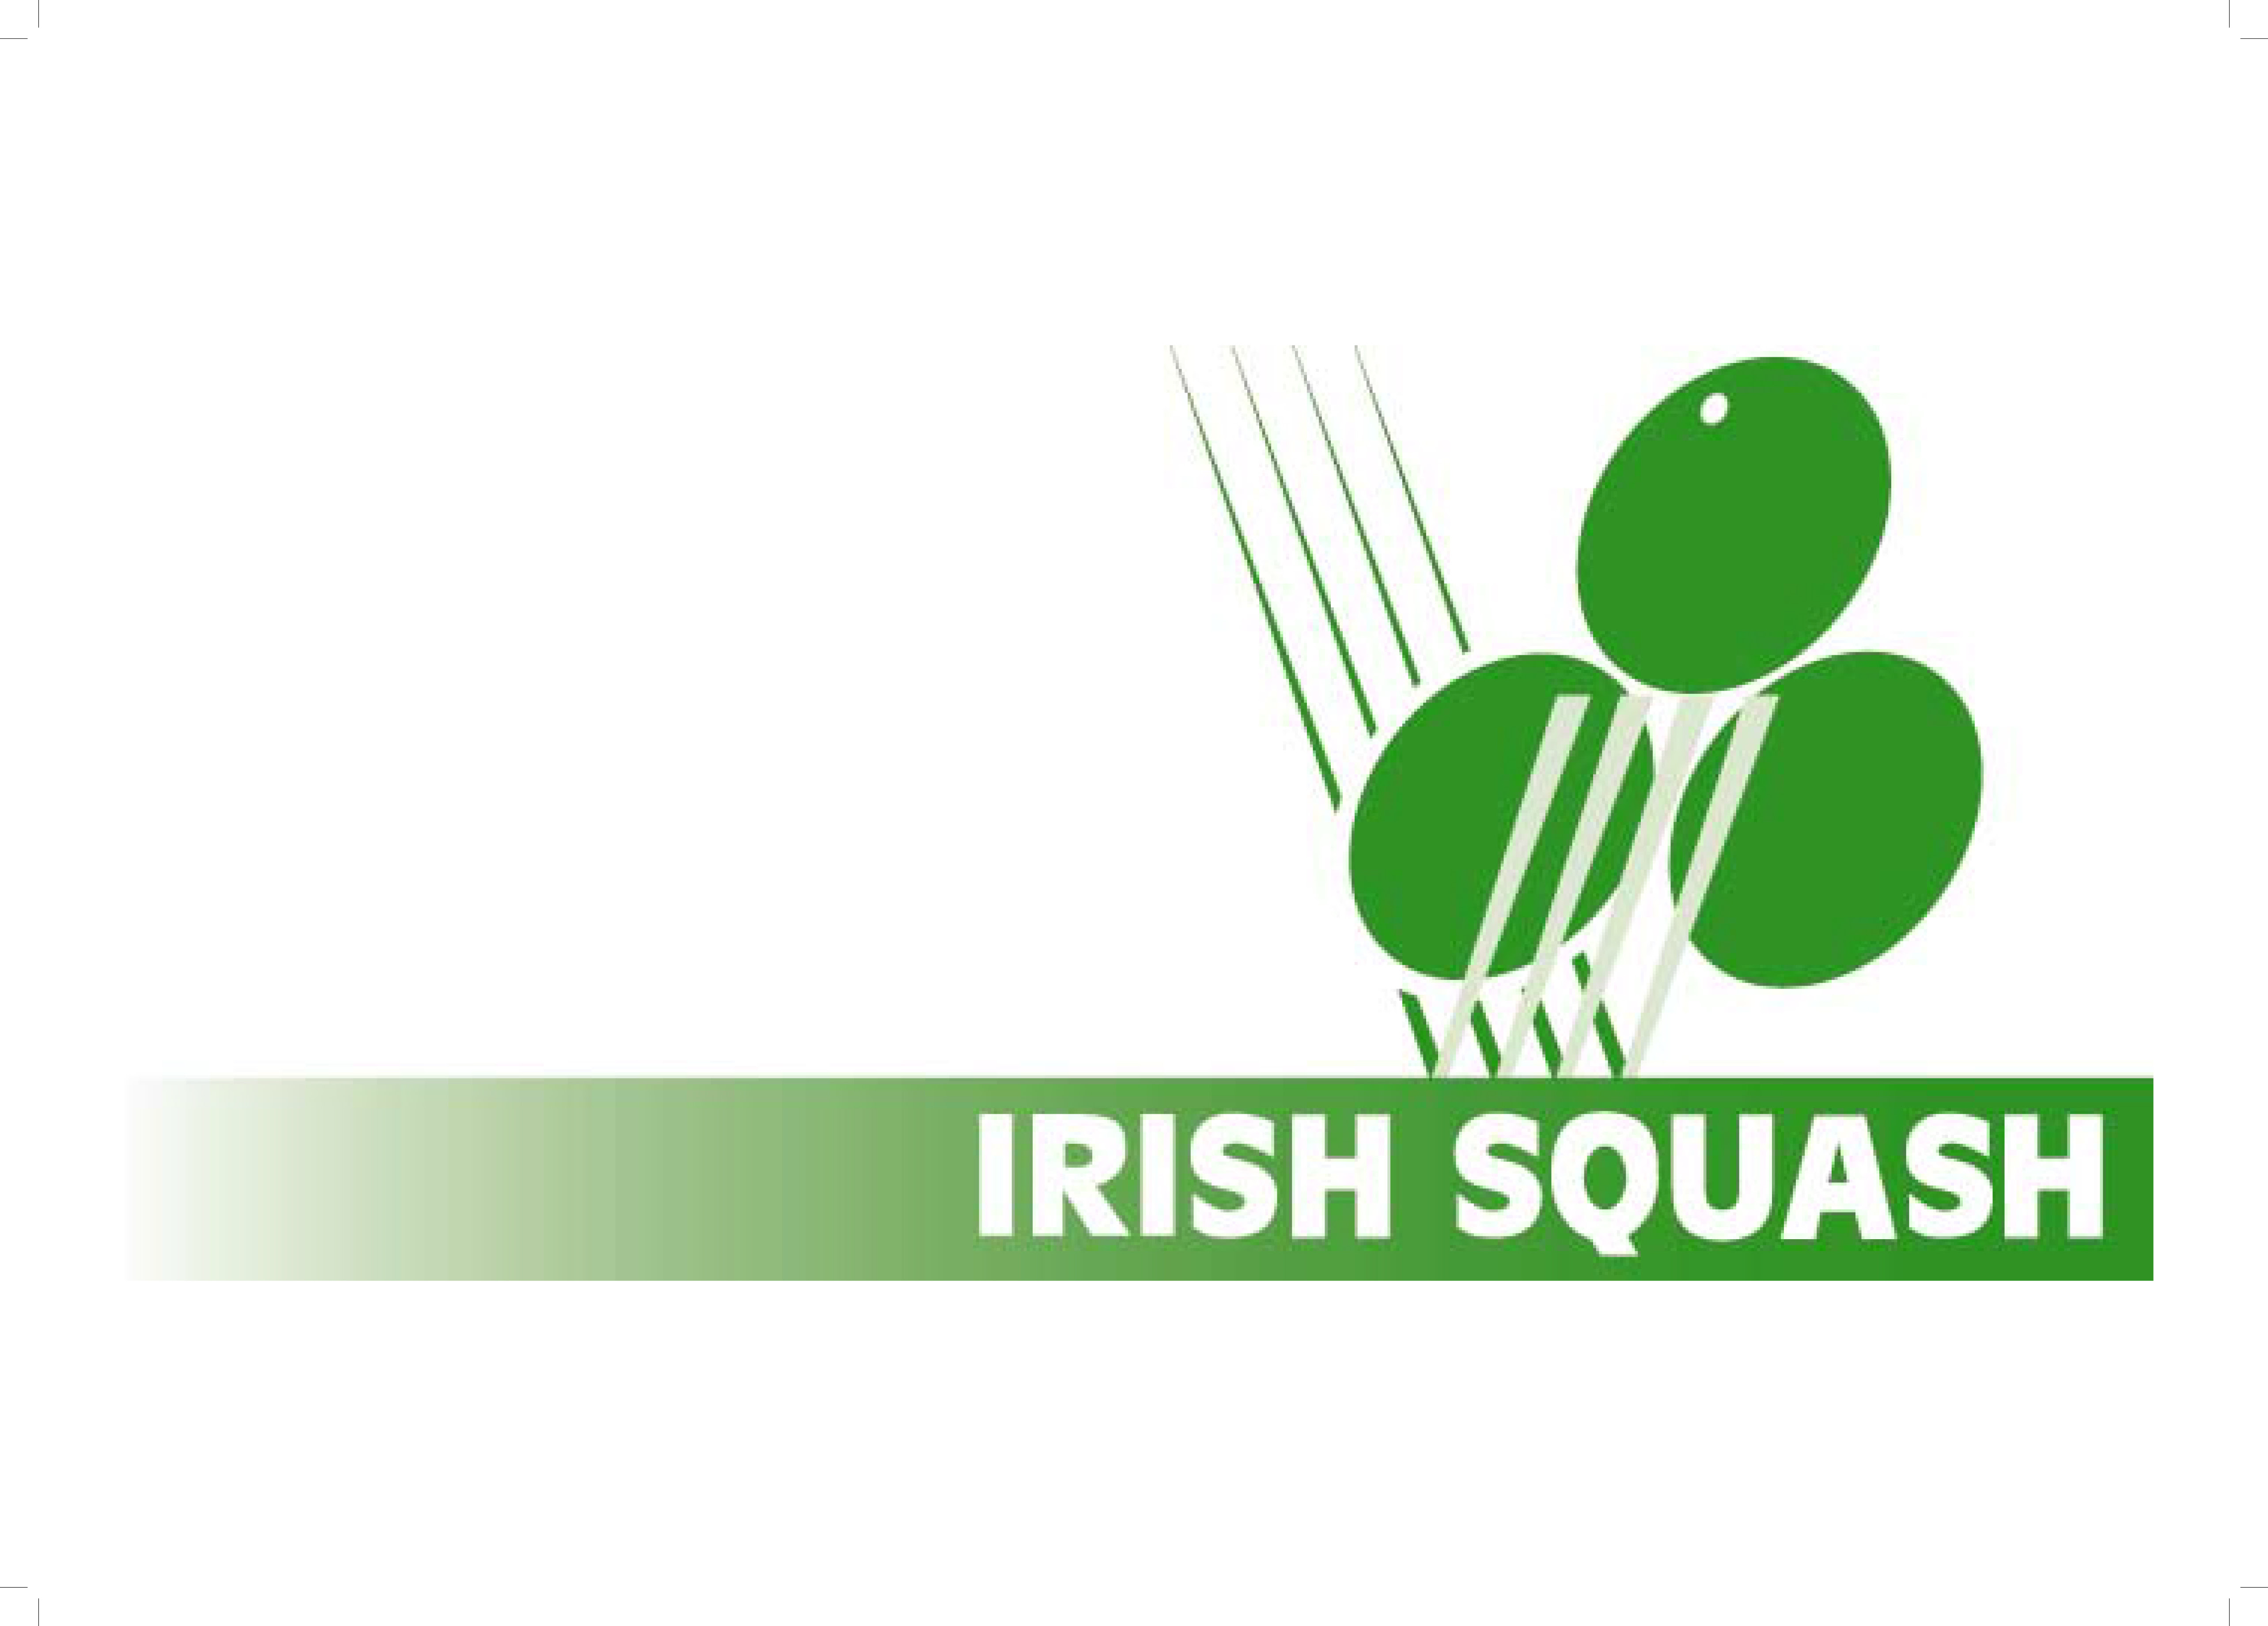
Date 10/11/19
Gerry Callanan
Masters Secretary
masterssecretary@irishsquash.com

Irish Masters Tour News
The Leinster Masters open was the first Masters tour event of the season with over 100 entries The Event was run by Leinster Masters new president Hugh Fitzsimons along with Aidan Dillon who handled the draws and entries and Tom Kennan the treasurer. Brian William was tournament referee.
Our thanks to all of them for giving up there time and coping with the unprecedented numbers
There were 23 ladies entries up from 14 last year mainly we would like to thank Orla O’Dohertys for her help on getting the interest up with her coaching weekends
It has been agreed that’s any player who pulls out in future for a reason other than injury will get zero points and not be allowed play later matches in that event.
The Leinster masters had some issues with refereeing, so it has been decided that at next event we will trial , the two players coming off court will have to mark and referee the next match on court. This will take the pressure off the organisers of the other events this year and bring us in line with similar ESF events

Ranking News
The first event of season was seeded using the new rolling rankings system.
There only had to be one wild card used in the event for Eoin Ryan who won the overs 50s mens.
The new rankings were updated straight after the event

Home International News
There is a proposal from Scottish squash to run an over 80s event this year. We have two players confirmed but wales are having difficulty so we are not sure if it will go ahead this season.

ESF Tournament News
We have tendered for and Irish Open event in 2020 with tenders only closing on 31st October we await a decision.
Orla ‘Doherty added to her European masters title by winning the Malta Maters over 45s
David Ayerst won the mens over 45s at the recent German Masters Open

AOB
We are in the process of setting up Irish masters as a club on ipros sports similar to England squash for team gear. We hope to have sample sizes at next masters event so ordering online will be easier,
Save the date Saturday March 7th
Following the Irish close masters event there will be a gala dinner with prize giving and entertainment hopefully all masters players partners and ex-players will come along.

Next Event
Connacht Masters Open entry link below

http://www.tournamentsoftware.com/sport/tournament?id=913959B6-F89B-4F6E-81D5-649A24B98D3E

