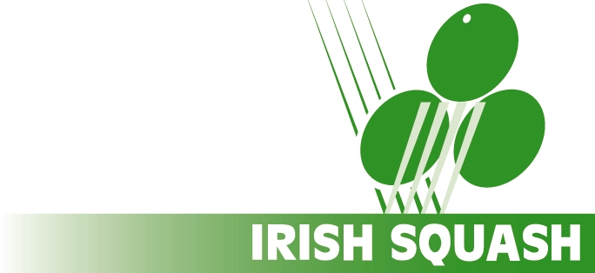

Irish Squash Federation clg

Irish Squash is fully committed to implementing the guidelines of Sport Ireland Safeguarding Children policy.
Irish Squash has its Safeguarding policy which can be viewed on our website - https://www.irishsquash.com/safeguarding-children/

Children’s officers have been appointed in squash clubs with junior members throughout the country, to create a safe and fun environment for our junior players. All coaches/leaders working with children must be vetted and have safeguarding training. See here re training - https://www.irishsquash.com/safeguarding-children/

Forms are available on the Irish Squash Website for Coaches/Selectors/Team Managers or for Volunteers working with Irish Squash.
To complete a form you will need to provide the names and addresses of two people who know you (but who are not related to you) and who would have experience of you working with children, who would provide you with a reference. Completed forms should be returned to: Irish Squash on info@irishsquash.com along with the reference from the 2 people.

Irish Squash requires all adults working with children in the ROI & NI to be vetted by the Garda Vetting bureau in ROI and in NI vetted by Access NI.
Vetting forms are available on the Irish Squash website. Please follow the procedure on the website – https://www.irishsquash.com/garda-vetting/

Yours in sport,
Ann Sheppard
Irish Squash National Children’s Officer



