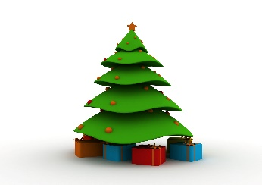
This Photo by Unknown Author is licensed under CC BY
This Photo by Unknown Author is licensed under CC BY
This Photo by Unknown Author is licensed under CC BY

A coach is not just for Christmas....

To all Irish Squash affiliated clubs and registered coaches

Irish Squash are holding a free Christmas raffle for junior players
There are 10 prizes, each prize is a voucher for a 2-hour coaching session with the coach of their choice from the list below.
The vouchers are valid for all of 2021.

Clubs and coaches please fill in the attached spreadsheet with entries for the raffle and send to info@irishsquash.com by 5pm on Monday 4th January 2021. Winners will be announced on Wednesday 6th January via the Irish Squash website.
Players can only enter once. Players, please contact your club or coach to get your name on the list.
Upon completion of coaching session, can winners take a selfie with coach for publication on Irish Squash website
List of participating Coaches

Gerry Connaughton/Jenny Dillon/John Dineen/Kieran Doherty/Frank Donnelly/Christopher Engel/Gerry Galvin/Andrew Gillespie/ Lee Healy/Kevin Knox/David Noone/Kevin Quinlan/Eoin Ryan
This Photo by Unknown Author is licensed under CC BY
This Photo by Unknown Author is licensed under CC BY
This Photo by Unknown Author is licensed under CC BY

