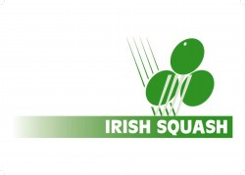
Irish Squash Challenge 1 - August 27th - 29th
Q-Final S-Final Final Winner
Conor Moran (1)
Friday
5.30 pm.
Todd Gowdy (8)
Peter McNiece (7) | Saturday 12 pm.
Friday
7.30 pm.
Gavin L'Estrange (4)
Alex Smith (3) |  | Sunday 12 pm.
Friday
8.30 pm.
Oisin Logan (5)
Denis Gilevskiy (6) | Saturday 1 pm.
Friday
6.30 pm.
Sam Buckley (2)

