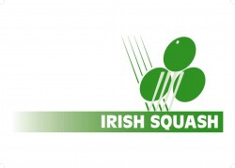

Irish Squash Challenge 1 - August 27th - 29th

**Q-Final S-Final Final Winner**

|  |  |  |  |  |
| --- | --- | --- | --- | --- |
| **Conor Moran (1)** | **Conor Moran (1)** |  |  |  |
| *Friday* |
| *5.30 pm.* | 11/8 11/6 11/1 |
| **Todd Gowdy (8)** |
| **Peter McNiece (7)** | *Saturday 12 pm.*  **Gavin L'Estrange (4)** |  |
| *Friday* |
| *7.30 pm.* | 11/5 7/11 9/11 11/7 11/9 |
| **Gavin L'Estrange (4)** |
| **Alex Smith (3)** | **Oisin Logan (5)** | *Sunday 12 pm.* |  |
| *Friday* |
| *8.30 pm.* | 13/15 11/5 11/7 7/11 12/10 |
| **Oisin Logan (5)** |
| **Denis Gilevskiy (6)** | *Saturday 1 pm.*  **Sam Buckley (2)** |  |
| *Friday* |
| *6.30 pm.* | 11/5 9/11 11/5 11/3 |
| **Sam Buckley (2)** |