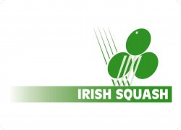
Irish Squash Challenge 1 - August 27th - 29th
Q-Final S-Final Final Winner
Conor Moran (1) |  | Saturday 12 p.m. | Sunday 12 p.m.
Fri
5.30 p.m.
Todd Gowdy (8)
Peter McNiece (7)
Fri
7.30 p.m.
Gavin L'Estrange (4)
Alex Smith (3)
Fri
8.30 p.m.
Oisin Logan (5)
Denis Gilevskiy (6) |  | Saturday 1 p.m.
Fri
6.30 p.m.
Sam Buckley (2)

