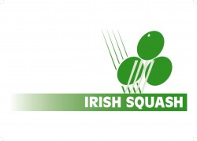 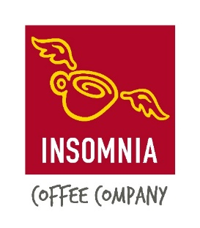

Insomnia Coffee Irish Squash Challenge 2 - September 17th - 19th

**Q-Final S-Final Final Winner**

|  |  |  |  |  |
| --- | --- | --- | --- | --- |
| **Sam Buckley (1)** | **Sam Buckley (1)** |  |  |  |
| *Friday* |
| *8.00 pm.* | 11/5, 11/6, 11/4 |
| **Cillian Dunne (8)** |
| **Denis Gilevskiy (6)** | *Saturday 12 pm.*  **Denis Gilevskiy (6)** |  |
| *Friday* |
| *6.00 pm.* | 11/6, 11/5, 12/10 |
| **Gavin L'Estrange (4)** |
| **Alex Smith (3)** | **Oisin Logan (5)** | *Sunday 12 pm.* |  |
| *Friday* |
| *7.00 pm.* | 11/7, 11/6, 8/11, 9/11, 11/6 |
| **Oisin Logan (5)** |
| **Todd Gowdy (7)** | *Saturday 1 pm.*  **Conor Moran (2)** |  |
| *Friday* |
| *7.30 pm.* | 11/2, 12/10, 11/3 |
| **Conor Moran (2)** |