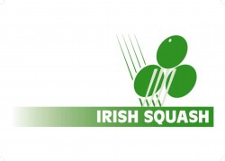
Irish Squash Challenge 2 - September 17th - 19th
Q-Final S-Final Final Winner
Sam Buckley (1)
Friday
8.00 pm.
Cillian Dunne (8)
Denis Gilevskiy (6) | Saturday 12 pm.
Friday
6.00 pm.
Gavin L'Estrange (4)
Alex Smith (3) |  | Sunday 12 pm.
Friday
7.00 pm.
Oisin Logan (5)
Todd Gowdy (7) | Saturday 1 pm.
Friday
5.00 pm.
Conor Moran (2)

