Masters Report
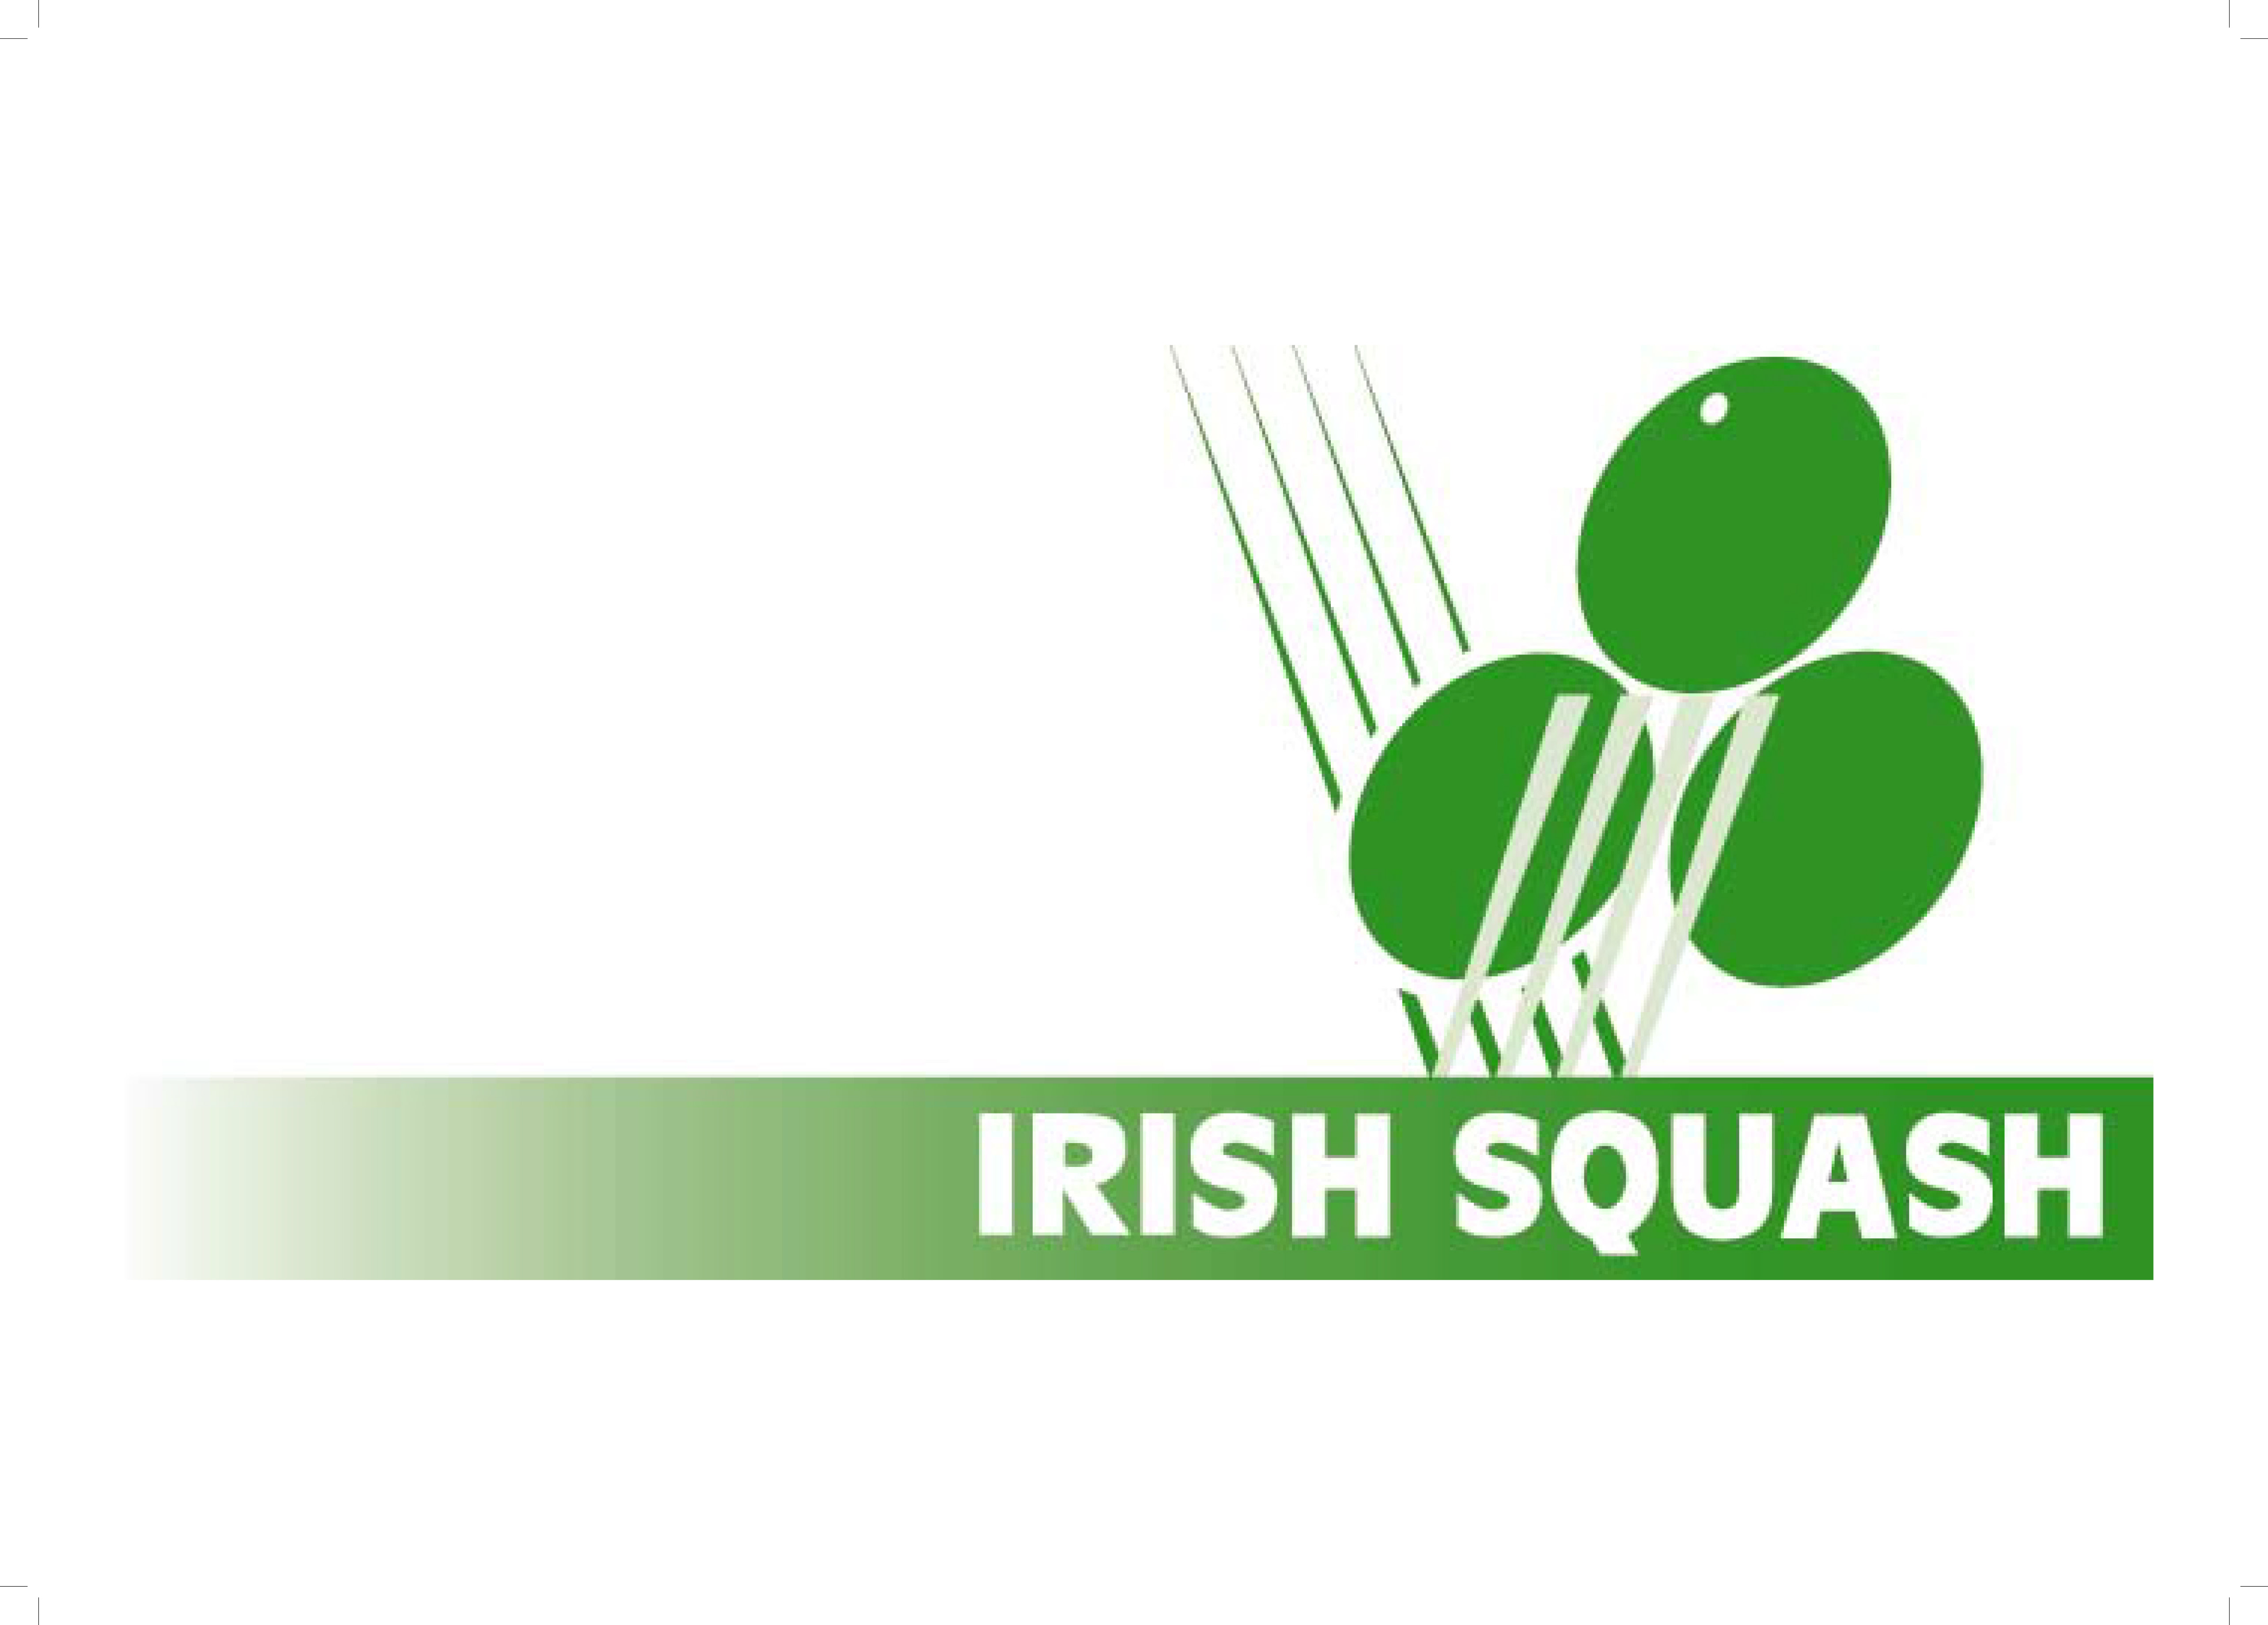
Date 24th September 2021
Gerry Callanan
Masters Secretary
masterssecretary@irishsquash.com

Irish Masters Challenge Event Friday 15th October and Saturday 16th October 2021
Hi All
Delighted to give you all details of our first tournament back for 18 months. The event will not carry any selection points as some people may not be ready yet to play a competitive event. The Connacht masters 5/6th November will be the first ranking event.
Gerry
Please see note below from Rosie Barry, President, Irish Squash
“ Hi Masters Players
Great to be back
SportyHQ is the new single platform software which will be used to run our tournaments. Entry and payment for this first Masters event in over 18 months can be made online (see link).
Players will need to establish their own profile on SportyHQ in order to enter the tournament. Some of you may already have a profile,
I encourage players to also download the mobile app which will enable you to score matches and simultaneously keep the tournament website updated!
SportyHQ will be used increasingly by Irish Squash in order to improve your squash experience both on and off court”.
Enjoy this Masters Challenge Event 2021
Rosie Barry President Irish Squash)

This tournament will unfortunately be for Covid vaccinated players only as per government guidelines.
The tournament will be played in a number of Southside Dublin venues. The number of venues will depend on entries.
Entry form will be found on www.sportyhq.com
Closing Date: Saturday October 9th
Where in future all Irish events will be found, you will need to set have an account here please see bottom of email for further instructions.
Payments for entries will done there as well as draws entries etc. The entry fee is 50 euros but this includes supper Friday and Saturday and a light lunch on Saturday hopefully you will all get a minimum 3 matches
There is a rate of 30 euro for no food package. There will be no food available at venues except the package which must be booked on entry
We have negotiated a preferential rate in the Mespil hotel
www.mespilhotel.com
Booking code for the 15 & 16th October is FITZ 151021
This must be booked by phone or email

Standard room €129 including breakfast per day
Superior room €139 including breakfast per day

Finally if anyone is interested in sponsoring any master events or part sponsoring they might contact me or let me know of someone who might be interested.

Some advice re player setup on sporty
- If an existing Leinster Master - played leagues then they should be there and can proceed to register.
- If they are totally new - not in league and never played a tournament then they simply create their profile in sporty and off they go
- If they have played in a tournament over the past few years then their profile/history should be there but they may not have their own login
If this is the case check out below - search the person on the Irish Squash List, ensure it's the right person (that the player history is ok) and they have an accurate email and then send the reset request to that person..

