___________________________________________________________________________________

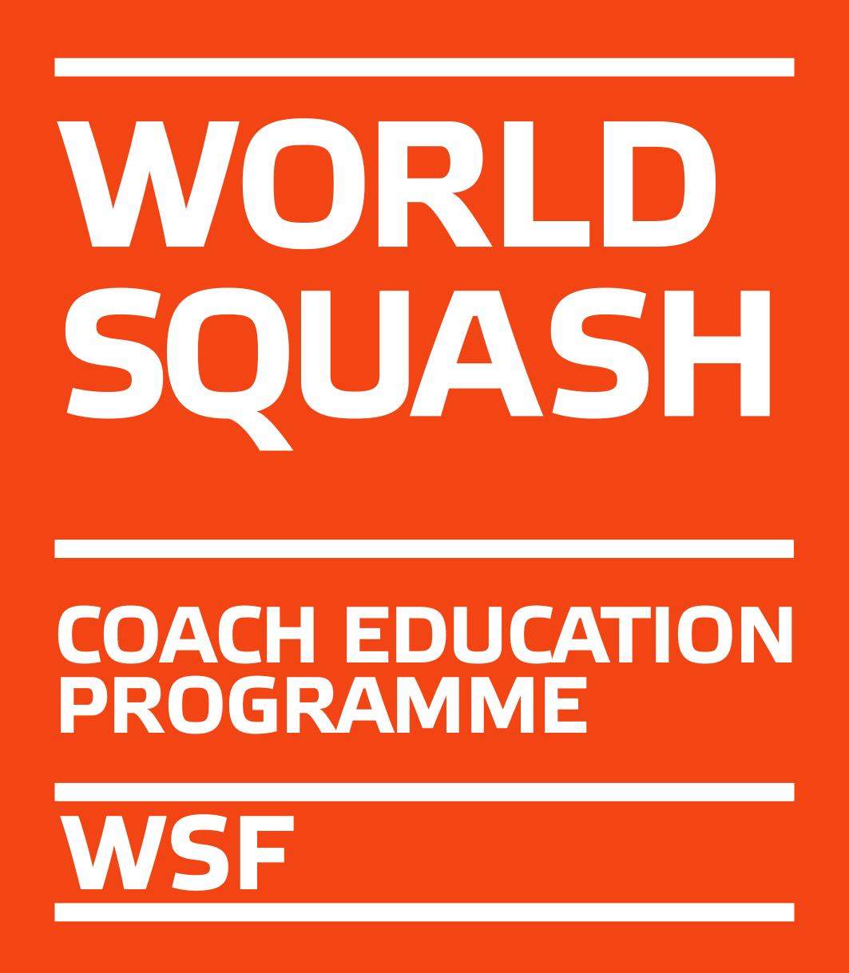

WSF Level 2 Coaching Course

Application Form

Send to: info@irishsquash.com
National Association: IRISH SQUASH

Name:

SPIN number:

Address:

Phone:

E-mail:

It is essential to answer all questions in order to be allowed to enter the course:

Details of Level 1 Coaching Diploma Course certificate held:

WSF Level 1 Coaching Diploma O

or

other equivalent Level 1 Qualification O

Name of Course/Qualification:

The course was organised by:

(name of National of Regional Federation)

Date & place where the course was passed:

Personal Coaching Experience:

Do you have coaching experience in another sport?

Do you have a formal qualification in Physical Education? If so, please state level of degree and institution:

How long have you been coaching squash?

How many hours a week do you coach?

What is the level of your pupils? O mainly early learners

O mainly intermediate players

O a mix of both

Do you give (multiple answers possible) O individual lessons

O group lessons with children

O group training with intermediate players

Please state the national ranking and category of your best pupil:

Indication of your personal playing level and experience:

How long have you been playing squash?

Have you played or do you still play squash at a competitive level?

If yes, please state you highest national ranking:

Once you have registered as Level 2 Coach Candidate you have access to all WSF Coaching Resources via your SPIN profile. We strongly recommend you read the L1 material before attending the course.

