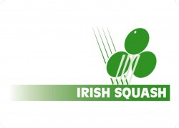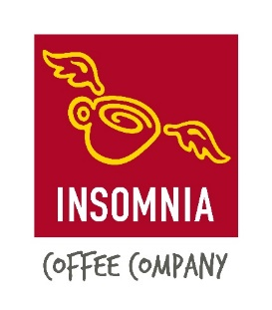
Insomnia Coffee Irish Squash Challenge 3 – October 8th – 10th
Q-Final S-Final Final Winner
Sam Buckley (1) | Sam Buckley (1)
Friday
6.30 pm. | 11/7 11/5, 11/6
Dylan Moran (8)
David Ryan (7) | Saturday 12 pm.  Gavin L’Estrange (4)
Friday
5.30 pm. | 5/11, 11/4, 9/11, 11/7, 11/6
Gavin L’Estrange (4)
Alex Smith (3) | Oisin Logan (5) | Sunday 12 pm.
Friday
7.30 pm. | 11/9, 6/11, 11/6, 11/3
Oisin Logan (5)
Denis Gilevskiy (6) | Saturday 1 pm.  Conor Moran (2)
Friday
8.30 pm. | 11/8, 11/3, 11/2
Conor Moran (2)

