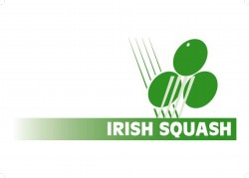 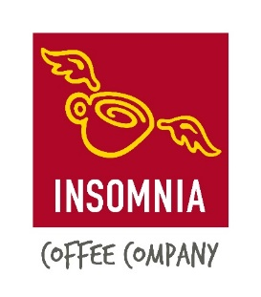

Insomnia Coffee Irish Squash Challenge 3 – October 8th – 10th

**Q-Final S-Final Final Winner**

|  |  |  |  |  |
| --- | --- | --- | --- | --- |
| **Sam Buckley (1)** | **Sam Buckley (1)** | **Sam Buckley (1)** | **Sam Buckley (1)** |  |
| *Friday* |
| *6.30 pm.* | 11/7 11/5, 11/6 |
| **Dylan Moran (8)** |
| **David Ryan (7)** | *Saturday 12 pm.*  **Gavin L’Estrange (4)** | 11/5, 11/9, 11/7 |
| *Friday* |
| *5.30 pm.* | 5/11, 11/4, 9/11, 11/7, 11/6 |
| **Gavin L’Estrange (4)** |
| **Alex Smith (3)** | **Oisin Logan (5)** | *Sunday 12 pm.*  **Oisin Logan (5)** | 11/6, 11/5, 10/12, 9/11, 11/9 |
| *Friday* |
| *7.30 pm.* | 11/9, 6/11, 11/6, 11/3 |
| **Oisin Logan (5)** |
| **Denis Gilevskiy (6)** | *Saturday 1 pm.*  **Conor Moran (2)** | 11/8, 11/8, 11/2 |
| *Friday* |
| *8.30 pm.* | 11/8, 11/3, 11/2 |
| **Conor Moran (2)** |