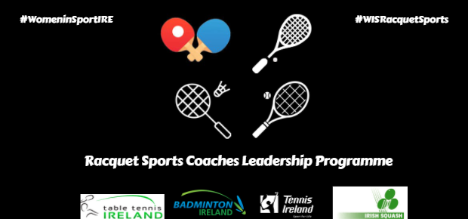
Racquet Sport Coaches Leadership Programme 2022
Overview:
Irish Squash , Badminton Ireland, Table Tennis Ireland, and Tennis Ireland are collaborating to create a network of like-minded women in a 'Racquet Sports Coaches Leadership Programme' who are all striving to be the best they can be as coaches and learn and collaborate with our four sports to create a community. The Programme will be a four-week programme, with three online informative sessions on chosen topics, consisting of one hour each, along with a face-to-face meeting.
Topics:
- Performance Analysis
- Psychology/ Mental Strength in Coaching
- Communication techniques/ Conflict Management
- Leadership
Criteria to Apply:
- Applicants must be females who are currently over the age of sixteen.
- Applicants must have completed the foundation level of their coaching qualification in their chosen racquet sport (Tennis Ireland - Play & Stay Assistant; Table Tennis – Teacher’s Award/Foundation Course; Badminton Ireland – Shuttle Time; Irish Squash – Leaders Course), or higher.
- Applicants must be able to shadow a qualified coach in their club.
- Applicants must be able to attend all four sessions. Provisional Dates – 4th, 11th, 23rd (face to face meeting) & 25th of April.
- Applicants who are under eighteen must obtain signed parental/ guardian consent on their application form.
** Please note, dates subject to change
- The course is FREE
- Closing Date for Applications : Friday March 25th @ 5pm

