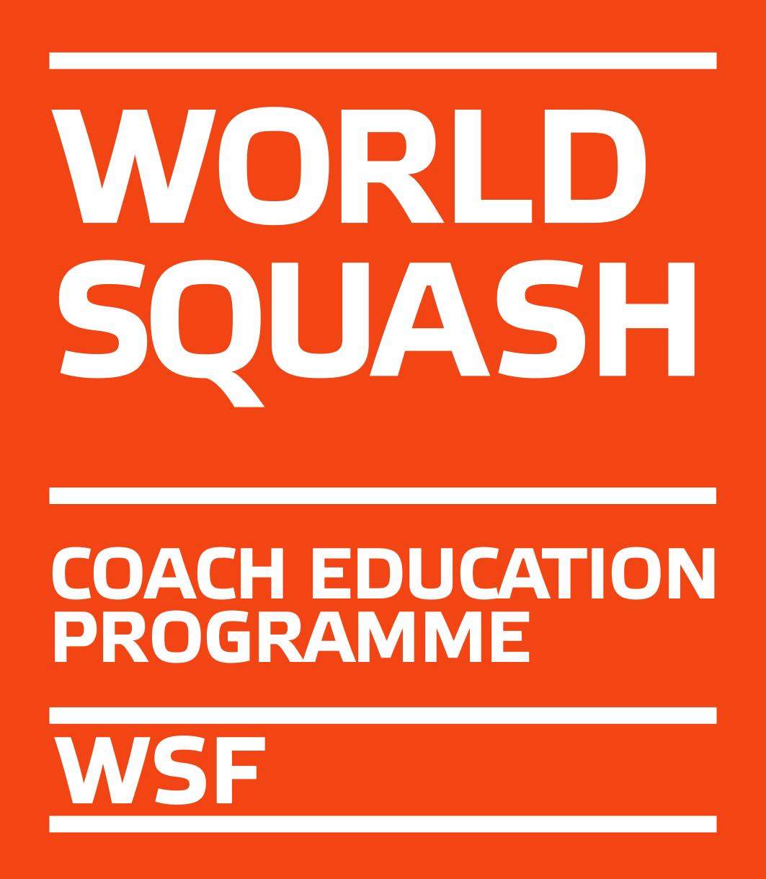
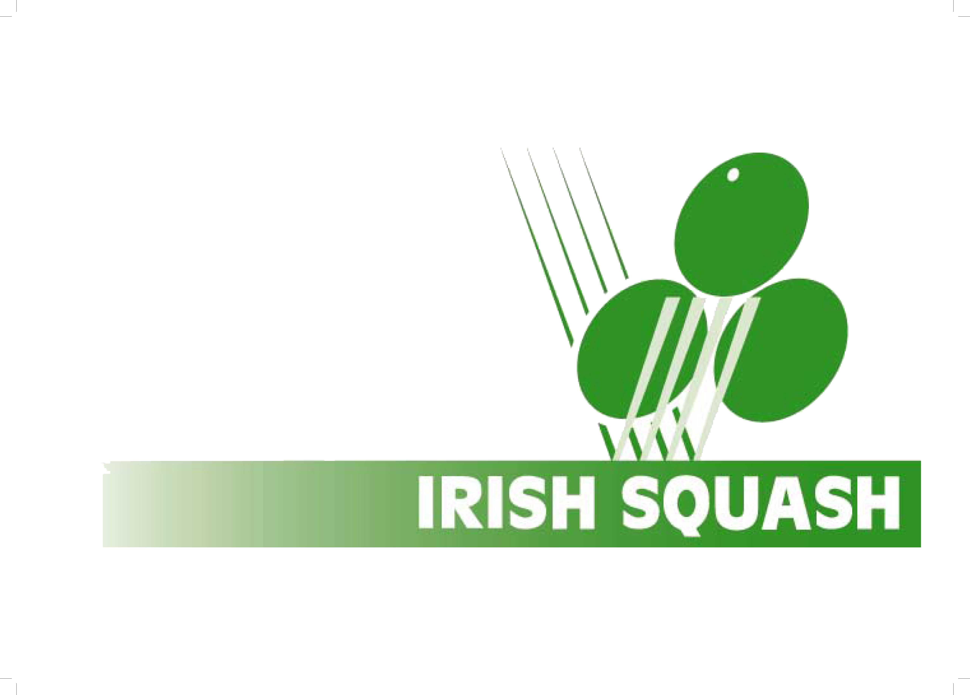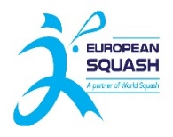

WSF Level 1 Coaching Course

On behalf Irish Squash we are pleased to invite you to a WSF Level 1 Coaching course. To be held in Munster.

Course organiser: Eddie Murphy
email: coacheducation@irishsquash.com

THE VENUE

Celtic SC, Waterford

Weekend 1 - 25th/26th June 2022
Weekend 2 - 9th /10th July 2022

Course Duration: The course will run for 4 days from 9.30am – 5.30pm with assessment on the final day. Each candidate must submit a video of themselves playing squash for 2 mins approx on Whatsapp to 087 2651645 prior to being accepted on the course.
Candidates will be on court and in class room during the course.

COURSE FEE

The course fee of €275 must to be paid upon entry to this link:

https://www.irishsquash.com/coaching-course/

As this course is part of the WSF Coach Education Programme, participants must register with their SPIN on the WSF website –

https://www.worldsquash.org/coaching-development/coach-education-programme/coach-registration/

as L1 Coach Candidate, which costs GBP 16. Please do this before the course starts.

Candidates must apply for Garda vetting details on the Irish Squash web site - https://www.irishsquash.com/garda-vetting/

Also you must attend a Safeguarding 1 course, see the Local Sports Partnership in the county you live, to register for a course. It is just €15 and takes one evening to complete. Search for a course here -
https://www.eventbrite.ie/d/online/safeguarding-1/?mode=search&page=1&q=Safeguarding

Courses are not in strict chronological order!

If you are under 18 then you will have to wait until you become 18 to do these.
You will get your coaching badge then if you are successful.

Application form is below

LEVEL 1

APPLICATION FORM

Send to:
irishsquash@gmail.com
Course in Celtic SC (please tick) ___

Name ________________________________________

Address ________________________________________

Tel ________________________________________

E-mail ________________________________________

Club where you will coach ________________________________________

Course Fee: €275.00. The course fee must be paid to Irish Squash before the start date of course in order to validate entry.

Please note:
Irish Squash reserves the right to cancel the course if there are insufficient entries to make delivery of course viable!

