Masters UPDATE
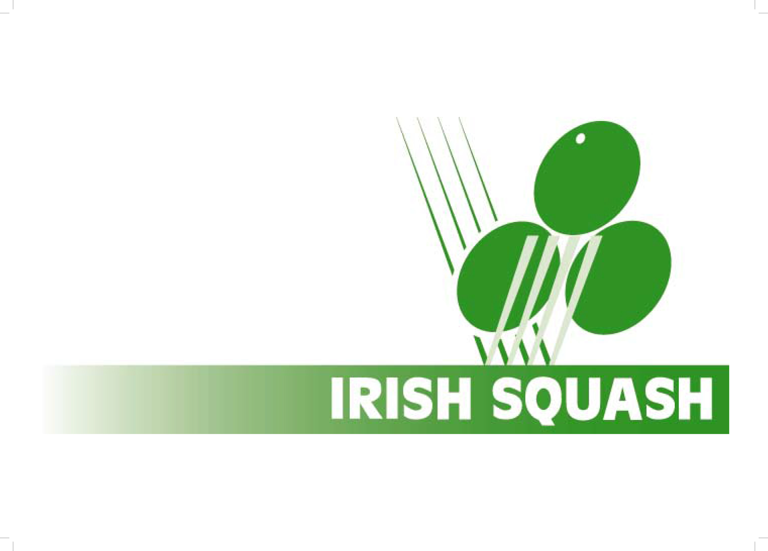
Date 13th June 2022
Gerry Callanan
Masters Secretary
masterssecretary@irishsquash.com

Summer Programmes for all Masters Players
Hi All
This week sees the start of the master’s summer training with Derek Ryan and Alex Fuller
Derek currently is strength and conditioning coach to Ali Farag and Mostaf Asal ,Derek will be doing a strength and conditioning sessions free online for the masters group funded by Irish Squash
Mondays 6p-7pm Strength and Conditioning (suitable for all levels)
Thursdays 7pm-8pm Mobility and Activations Classes ( suitable for all levels)
To Register please register on sporty hq once and we will send you an online link to the classes each week
REGISTER BELOW
https://www.sportyhq.com/tournament/view/Irish-Masters-Summer-SC-and-Mobility-Training-2020-1
Alex Fuller current Womens World Ranked 31 will be doing a series of one day and weekend squash camps for Women over the next 3 months.
These need to be signed up a week in advance of each session on sporty Hq there is a small charge for these which will include a light lunch.
The first camps will be 9th 10th July Dublin, the second camp will be second camp will be one day 24th July Dublin.
REGISTER BELOW
https://www.sportyhq.com/tournament/view/Irish-Masters-Summer-SC-and-Mobility-Training-2020

We will let you know on the future dates
provisionally they are 6/7 August,13/14 August. I will send on the entry links closer to the dates when confirmed

Yours
Gerry Callanan Masters Secretary

